**A flexible White-Rabbit node for PPS distribution system for the SKA Telescope**

Autores: Miguel, Felipe José Luis, Manolo? Javier

UGR (todos menos José, 7S)

## ABSTRACT

Resumen que se escribe más adelante.

## INTRODUCCIÓN

There are many mechanisms to distribute time information and signals. Some of them use GNNS receivers to get timing from the Satellites (GPS, Glonass, Galileo). Other use wired protocols to provide the time reference through the network. In all these cases is important to note that it is not the same to distribute frequency (it is about sending the oscillator signal through a wire or provide a mechanism to regenerate the clock frequency) than distributing phase information (in all the elements of a network the events trigger exactly at the same instance). The first problem is called synthonizaton whilst the second is the synchronization. In the phase distribution scenario we can encode the phase information on a pulse that is transmitted thought the wire periodically each second and use this as reference to know when a new second starts. This is typically called PPS (Pulse Per Second) signal. Finally, the last problem is the provision of the time. This is not only ticking at the same time, having the same reference about when to start the counting but also having the same time in all the devices. This can be distributed by propagation of the time information from a central time server and then, by measuring the propagation time of this message, annotating it in each node. Having these three elements, frequency, phase (PPS) and time we can say that the network is synchronized.

In this contribution we focus on finding a solution to provide ultra-accurate PPS signal distribution for the Square Kilometre Array (SKA) Telescope [2]. It is an international project to build a radio telescope tens of times more sensitive and hundreds of times faster at mapping the sky than today’s best radio astronomy facilities. It will become the world’s largest radio telescope. But the SKA is not a single telescope, but a collection of various types of antennas to be spread over long distances. Once completed it will generate data at a rate more than 10 times today’s global Internet traffic. The SKA will be used to answer fundamental questions of science and about the laws of nature and imposes a technological challenge never faced before.

In this contribution we present a new device based on the technology called White-Rabbit [REFERENCIA] to be used as mechanism for ultra-accurate PPS signal distribution. Section 2 will present the SKA Telescope project, the different network and the timing requirements that explain why an industrial technology solution is not feasible for SKA. In Section 3 we focus on the fundaments of the White-Rabbit technology. Section 4 describes the node we have proposed as end-node for SKA Telescope including the justification the proposed architecture and software support. The synchronization performance under different scenarios, network topologies and environmental conditions are finally presented on section 5 illustrating the goodness of the proposed solution. Final remarks are described on the section 6.

## the SKA Telescope

The Square Kilometer Array (SKA) [2] will be the largest radio-telescope of the world. Located in two different geographical areas (South-Africa and Australia/New Zeland) it will be one of the great physics machines of 21st Century and, when complete, one of the world’s engineering marvels. It will be constructed on different phases SKA1 (phase 1 2018-2023) and SKA2 (phase 2 2023-2033). The development will be deployed using on two different pathfinders existing on each place (MeerKAT in South Africa and ASKAP in Australia).

The key Science goals for this instrument are:

* Formation of the 1st galaxies in a dark Universe dominated by atomic gas
* Evolution of the atomic gas till the current epoch
* Strong Field Tests of Gravity Using Pulsars and Black Holes
* Acceleration in the expansion of the Universe not understood yet
* Habitable extra-solar planets (proto-planetary disks, biomarkers)

The SKA facility will use different kind of antennas targeting different geographical locations and time schedule. During SKA1 and according to the SKA1 System Baseline description [1], for building such facility two different kinds of antennas will be used according to their capabilities to sense. They are:

* SKA-LOW, 50 - 350 MHz Australia, 131,000 aperture array dipole 512 stations of 256 antennas
* DISHES, 350 MHz - 14GHz South-Africa SKA1_Mid 350 MHz – 14 GHz 64 MeerKAT dishes plus additional 133 SKA1 dishes.

The SKA1 telescope is being designed to optimize the Telescope performance. Some key facts about both types of instruments are shown on Fig. 1.

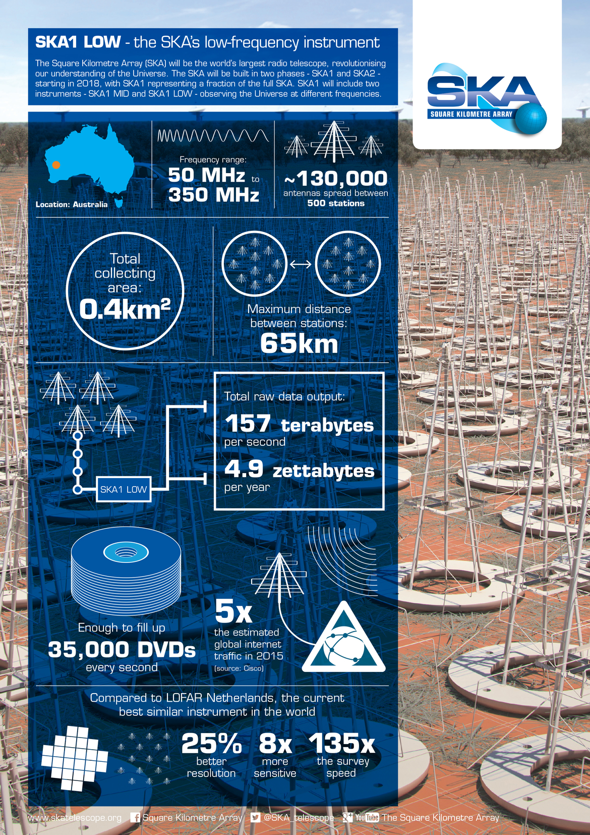 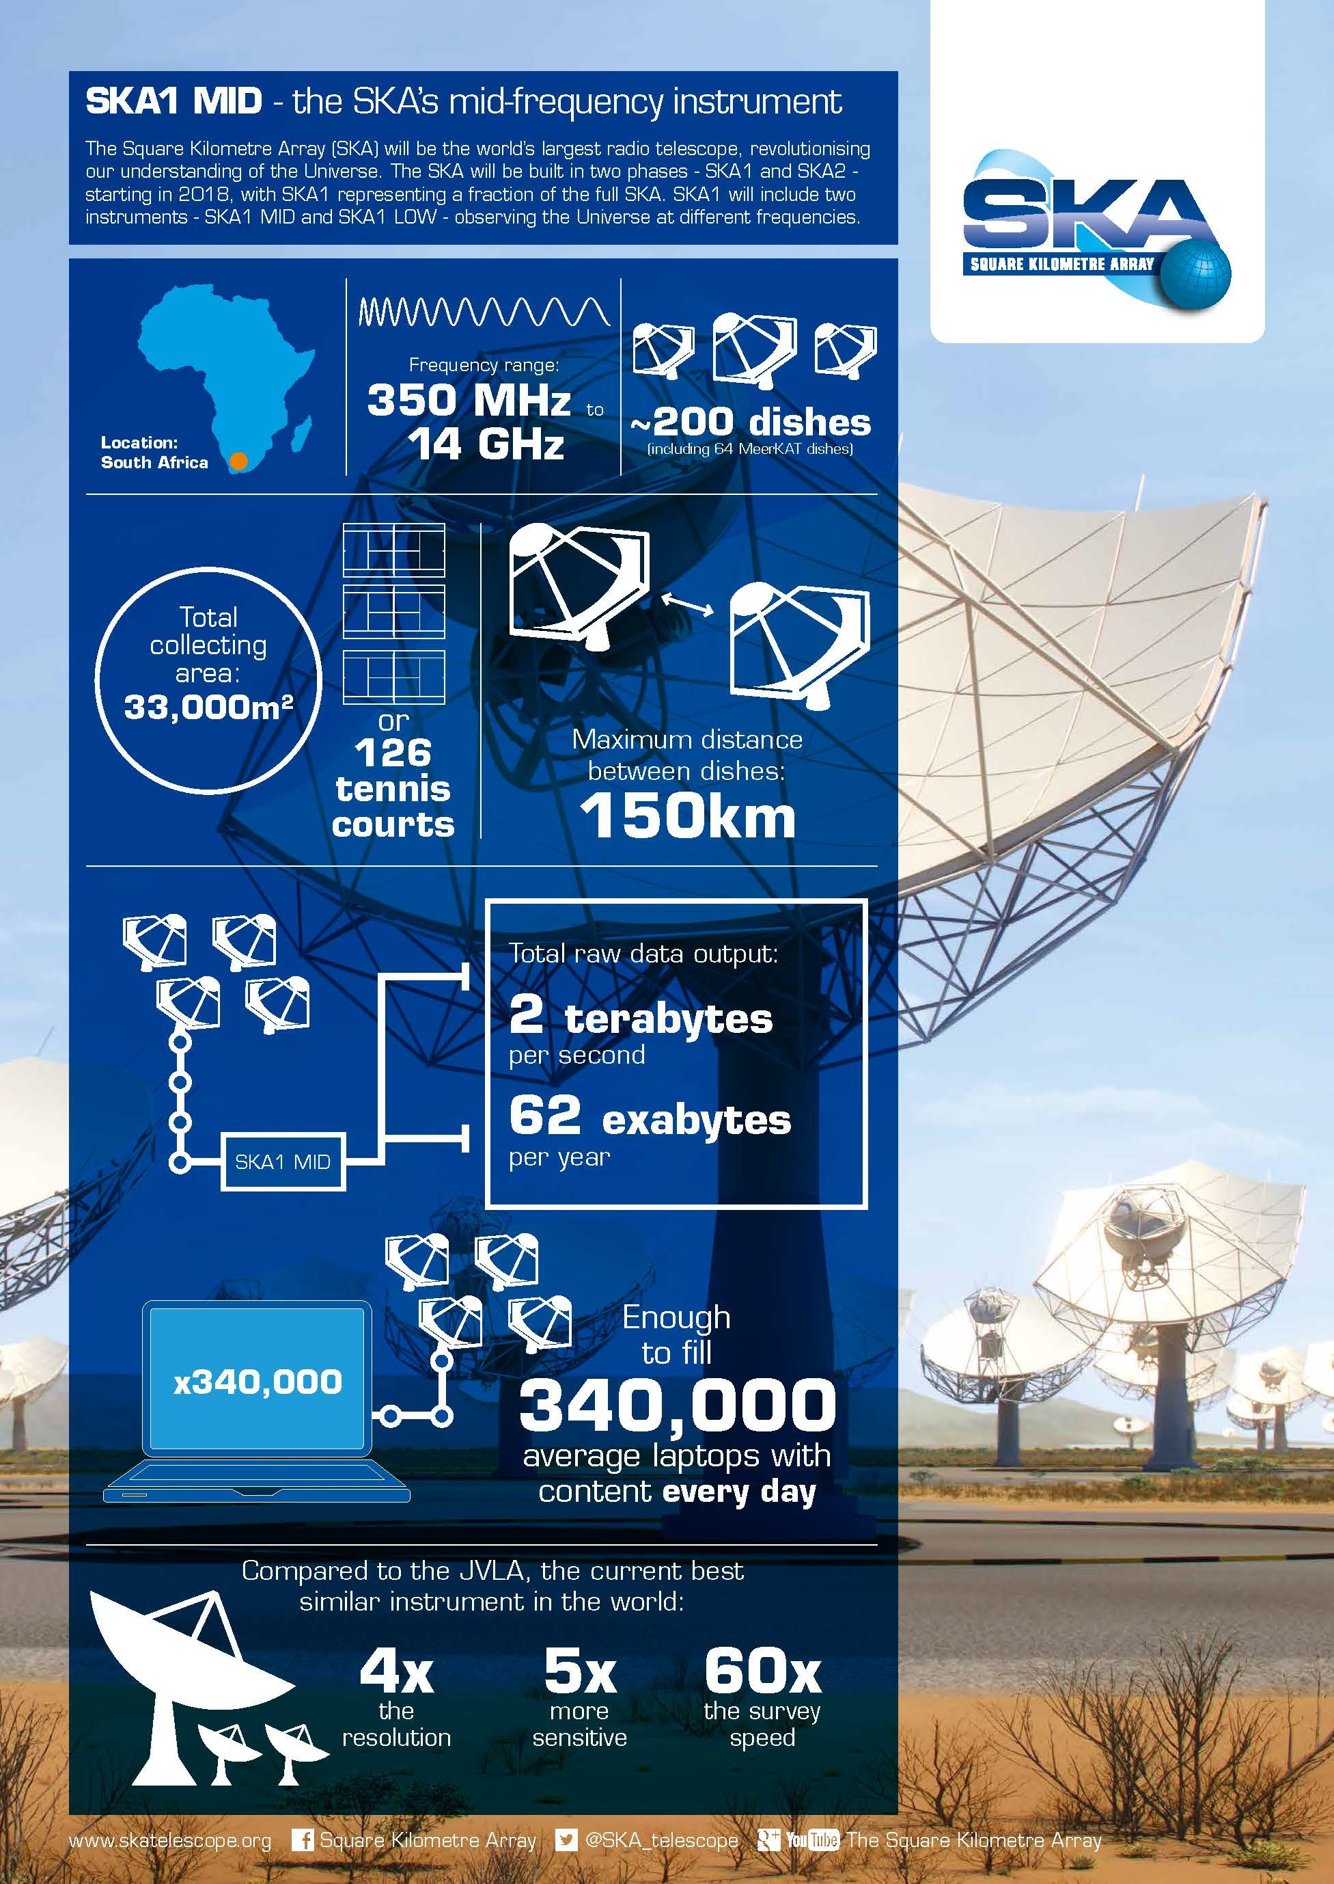

Figure 1. The SKA’s low frequency (left) and the mid-frequency (right) instruments. SKA Telescope will be build on two different phases. These images (adapted from <http://www.skatelescope.org/multimedia/image/>) illustrate key numbers corresponding to SKA1 phase (starting 2018).

The scale of the SKA Telescope represents a huge leap forward in both engineering and research & development towards building and delivering a unique instrument, with the detailed design and preparation now well under way. The unprecedented high performance specifications requires the utilization of best technologies and design strategies possible and represent an unprecedented challenge for all the elements to be build.

### Ska Telescope network

The SKA Telescope use different types of networks to guarantee a proper operation of the infrastructure. The design corresponds to the Signal and Data Transport (SaDT) element [3]. It includes all hardware and software necessary for the transmission of data and information between the Elements of the SKA. SADT also includes the provision of timing which is critical for interferometry.

The network data network includes the Digital Data Backhaul (DDBH) that transports signals from the radio telescopes to the Central Signal Processor (CSP), and data products from the CSP to the Science Data Processor (SDP) and from the SDP to the regional SKA Data Centres. The total data rates are very high, approximately 80 Tb/s for the DDBH links and another 80Tb/s for the CSP links.

Also covered by the SaDT is the Monitor and Control (M&C) that transmits and receives monitoring and control information throughout the system and includes the Telescope Manager, itself comprised of three logical networks: Production Network, Engineering Network and Safety Network, the Network Manager as well as local monitoring and control.

The final part of the SaDT is the Synchronisation and Timing (SAT) that provides frequency and clock signals from a central clock ensemble to all elements of the system to maintain phase information to the required accuracy for all receptors, and timing signals for data identification and time critical activities at the receptors, and the CSP and SDP. To maintain phase coherence across the array requires short-term timing precisions of around 1pico-sec, while for the requirements for the long-term timing for pulsar require 10 ns accuracies over 10 year periods. The timing is critical to the functionality of the SKA to work as a unified large telescope using a technique known as interferometry. In this contribution we will focus on the high accuracy synchronization method used for SKA1 responsible to provide a PPS (Pulse Per Second) signal to the critical elements.

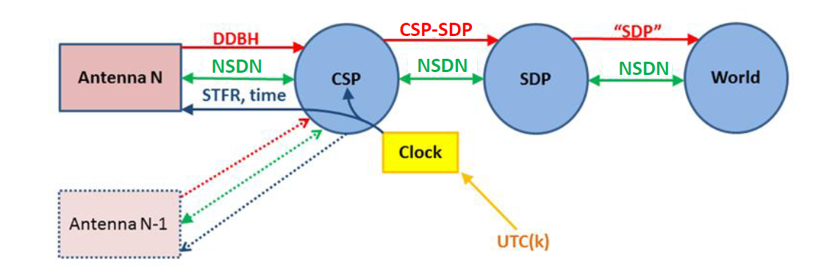

Figure 2. The SKA Telescope network architecture is composed by three networks: the data network (red), the M&C network (green) and the SAT network (blue). An external clock reference, UTC traceable, is provided to the whole Telescope elements in order of providing an unique time reference.

### Distribution of high accuracy timing signals for ska1

As determined by SaDT, SKA telescope should be able to distribute a commune frequency reference to all the telescopes and, in addition, provide a uniform time reference to timetags all the events with ultra-high accuracy. This task is done by the SAT (Synchronization and Timing) element that belongs to SaDT. The SKA timescale is maintained by the central clock ensemble for each telescope and will be steered to within designed limits of UTC (Coordinated Universal Time) and monitored with respect to UTC via GNSS time transfer techniques. These clock ensembles form the fundamental timescale for SKA and will be the basis for precision measurements of pulsars and other time-dependent phenomena. As consequence, during this distribution, UTC refers to UTC (SKA), as realized by the central SKA clock ensemble.

In this contribution we will focus on the solutions to distribute the UTC time by means of PPS (Pulse-Per-Second signal). This PPS signal guarantees that all the scientific data are time-tag using a commune reference. This time reference has high requirements coming from science that are not mandatory by other elements of the SKA systems as the monitor and control network. For these other elements, standard time transfer protocols as NTP or IEEE-1588 are a feasible solution. For the Telescope core, we illustrate that the high performance requirements imposed by the challenging Scientifics goals force to provide much more sophisticated solutions.

The PPS distribution system will be in charge to deliver its output at the following locations:

* Each of the 133 dishes of SKA1-MID, and once to the Meerkat system. The maximum receptor baseline lengths are between 120-150 Kms.
* The core of SKA1-LOW, and the 45 stations in total along the 3 spiral arms. The maximum receptor baseline lengths are between 70-80 Kms.
* The encoded absolute time signal will be delivered to each of the three CSPs.

Note that if the offset frequency scheme is to be applied to all SKA1-Mid dishes, an additional 64 STFR endpoints will be needed in SKA1-mid. This provides between 182 and 246 endpoints to synchronize.

The general array SAT requirements for the frequency distribution is 1ps while the time synchronization and timestamp requirement is 10ns. SaDT uses different mechanisms for achieving goals, frequency dissemination and PPS distribution. As consequence, because our goal in this contribution is just describing a solution for PPS distribution, we only focus only on the second requirement, the 10 ns synchronization as needed for example for the long-term timing Pulsar studies. Note that a complete description of the SKA network elements and topology is out of the scope of this contribution and we will just present the requirements needed to properly understand the need of the solution here developed.

It is important to remark than the 10ns requirement is the time-buget allocated for the whole network. Because elements such as main clock also consume part of this budget, this translates into PPS-distribution time budget of 5ns. The error budget here includes PPS distribution, delay centre precision, Dish timing transport and time-stamping errors. This time-budget should be distributed on the different elements of the system that rely on the network topology that determine the number of hops. Based on current SAT network topology, the target specification for the elements of the PPS distribution system provides them an average time-budget better than 2ns. This is a quite challenging goal not only because impose a high accuracy synchronization goal but especially having into account the installation environmental conditions. The SKA1 use aerial optical fiber networks that are significantly affected by the large temperature excursion during operation, more than 50º due to the installation on desert locations of Sud-Afrika and Australia. Furthermore the outdoor wind velocities during normal operation could achieve up to 40 Km/hr. This make the fibres oscillate, changing their length, which must be compensated on real-time during execution or averaged them out.

Next section will provide the description of the solution proposed to be use on SKA1 as mechanism for PPS distribution.

## the white rabbit synchronization TECHNOLOGY

INTEGRA ESTO CON LO TUYO. ESTO ES HABLAR SÓLO DE LA TECNOLOGÍA, SIN DETALLES DE DISPOSITIVOS O DE LA SOLUCIÓN

In the case of SKA, different solutions for time transfer were analyzed. For instance, GPS devices provide a reference frequency (10-50 MHz), a PPS signal and a serial code to provide the time (typically based on the NMEA protocol). This approach is widely used in many systems that require accurate synchronization (since different instrumentation can be easily connected to different GPS receivers) but it is sensitive to jamming issues. Alternatively, with the quasi-omnipresence of packet networks, the timing protocols are little by little imposing as main solution for time transfer over the network. Low performance protocols as NTP (Network Time Protocol, the protocol used in internet to synchronize the computers through the network) [REFERENCIA] are widely used while for industrial applications the preferred protocol is the IEEE-1588v2 (known as Precision Time Protocol or PTPv2) [REFERENCIA]. IEEE-1588v2 is an industrial evolution of NTP, characterized by the utilization of hardware time-stamping mechanisms that significantly improved time synchronization accuracy. Typically, NTP provides about 1ms synchronization accuracy while PTPv2, working on very well designed time-aware networks is able to achieve about 50ns synchronization accuracy.

Although previous approaches are quite accurate, they are not appropriated to fulfill the specifications of the 2ns time-budget associated to the SKA1 telescope. As alternative solution, the utilization of the White Rabbit (WR) protocol has been proposed because it is an evolution of IEEE-1588v2 protocol and able to distribute an absolute time reference with an accuracy of 1ns. Equipment located at each endpoint delivers a 1PPS signal with its edge aligned to the start of the UTC second. Therefore, each telescope can then be phased up by observing the white light fringe on one or more bright, compact sources.

### overview of White-Rabbit solution

White Rabbit (WR) technology [REFERENCIA] is an extension of Ethernet for precise timing. It was conceived at CERN in 2009 but the early involvement of technology based industry in its development allowed increasing the TRL (Technology Readiness Level) very fast. Furthermore, from its very early stages, White Rabbit was launched as an open Sw/Hw initiative with sources available at the Open Hardware Repository [4].This encouraged different companies and research institutions to openly collaborate in its development. White-Rabbit is based on standard mechanisms, such as PTPv2 (IEEE-1588v2) and SyncE. It is compatible with them but properly modified to achieve the subnanosecond accuracy [REFERENCIAS A PAPERS CHULOS QUE DEN MEDIDAS BONITAS]. It inherently performs self-calibrating over long distance links and it is capable of distributing time to a very large number of devices with very small degradation.

White-Rabbit technology is an extension of Ethernet and it is being evaluated to be integrated in the next Precision Time Protocol standard (PTP, IEEE-1588v3) in the framework of a High accuracy profile. Nevertheless this technology in the origin was not designed to address large distances or provide embedded nodes with monitoring and dependable mechanism. Although SKA1 is working on improving both issues, we particularly focus on this contribution on providing a novel platform capable disseminate the PPS signal ad with flexibility and dependability characteristics.

White Rabbit provides sub-nanosecond accuracy and picoseconds precision of synchronization for large distributed systems. It also allows deterministic and reliable data delivery. White Rabbit allows you to measure time-tag data precisely and lets you trigger data taken in large installations while at the same time using the same network for data transmission. The White-Rabbit synchronization mechanisms are implemented in the WRC (White-Rabbit Core) and include the following elements:

* Frequency synchronization (synthonization): this is obtained by using SyncE standard that encodes the clock signal in the data carrier. A mechanism based on a local oscillator disciplined to the external clock recovered from the optical link is used in order to guarantee that all the nodes use the same frequency.
* Phase synchronization. The physical clock of a node is retransmitted to the master element and viceversa so that master can compare the phase of this signal (coming from the slave) with its own phase. The deviation should be equal to the propagation time of the signal through the fiber (properly measured using PTP protocol). Having this information, the master can determine the phase difference between its own clock and the one from the slave and request him to shift its phase to exactly the same value as the master. This process is done digitally by implementing a DDMTD (Digital Dual Mixer Time Difference) in the FPGA gateware.
* Time synchronization. This is a consequence of using PTPv2 protocol that measures the link propagation times and provides the global notion of time. White-Rabbit also takes into account the asymmetries in the propagation time due to the utilization of different wavelengths in a bidirectional optical fiber for each communication transfer (back and forward in the loop), improving consequently the accuracy of standard PTP protocol. Since the frequency and phase have been previously synchronized, we can guarantee the global notion of time in all the devices within the White Rabbit network.

All those operations are implemented in the WRC, partially using the proper FPGA gateware and partially using an embedded softcore. The White-Rabbit devices include the proper oscillators, PLL and timing electronics required to perform the previous clock operations.

FALTARÍA AQUÍ ALGUNAS LINEAS SOBRE EL PROTOCOLO ……

Next sections will present the main possible WR contributions for SKA time dissemination: WR Precision Time Protocol for clock propagation and the generation of PPS signal.

## a pps distribution WR-NODE BASED ON wHITE-RABBIT for ska

The White-Rabbit protocol requires a network topology similar to the ITU-T G.8275.1/Y.1369.1 standard, a IEEE-1588v2 telecommunication profile that describe a time-aware network capable to provide full timing support [5]. It uses a master time reference (SKA1 clock) that is distributed following a tree topology in a master-slave configuration (all White-Rabbit nodes has a behavior equivalent to the IEEE-1588v2 Boundary clock devices). The PPS distribution network uses two different kinds of devices:

1. Switches. The White Rabbit switches [6] are standard 1U height rack-mounted equipment. These are placed in the CSPs at each of the clock ensembles, and for SKA1-MID; one is placed halfway along each of the 3 spiral arms to regenerate the signal for the longest links. Each WR switch has 18 SFP cages.
2. The end-nodes. They consist of a WR-ZEN node [7] powered by a Zynq FPGA-SoC and placed on inside a 1U rack enclosure. These end nodes will be located at the cores of SKA1-LOW and SKA1-SURVEY, along their spiral arms, one for each SKA1-MID dish and one for each CSP.

The WR signal is generated by WR switches from the SAT clock ensembles. They receive a 10MHz reference and PPS signal, and use NTP or IRIG-B to determine the UTC time of each PPS edge. The output is transmitted via a single fibre to the majority of the destinations. WR signals can be transmitted up to a maximum distance of 120 km by using commercial SFPs. In cases where this maximum is exceeded, such as for SKA1-MID, an intermediate WR switch is required as a repeater. The switch would need to be accommodated in a hut or pedestal along the 3 spiral arms. The repeater would add a small (20ps) jitter penalty for the few stations that are connected beyond the repeater switches. This penalty only applies to the internal measurement of the PPS phase, and not to the jitter of the PPS itself which is directly divided down from the distributed reference frequency (so it is not coming from WR devices and this jitter do not affect the array performance). As the topology of the WR network is the same as that of the SKA network distributing the reference frequency, over a single fibre strand, the WR network will use the other half of the fibre pairs that are installed for the SAT network. A simple representation of this network architecture is illustrated on the next figure.

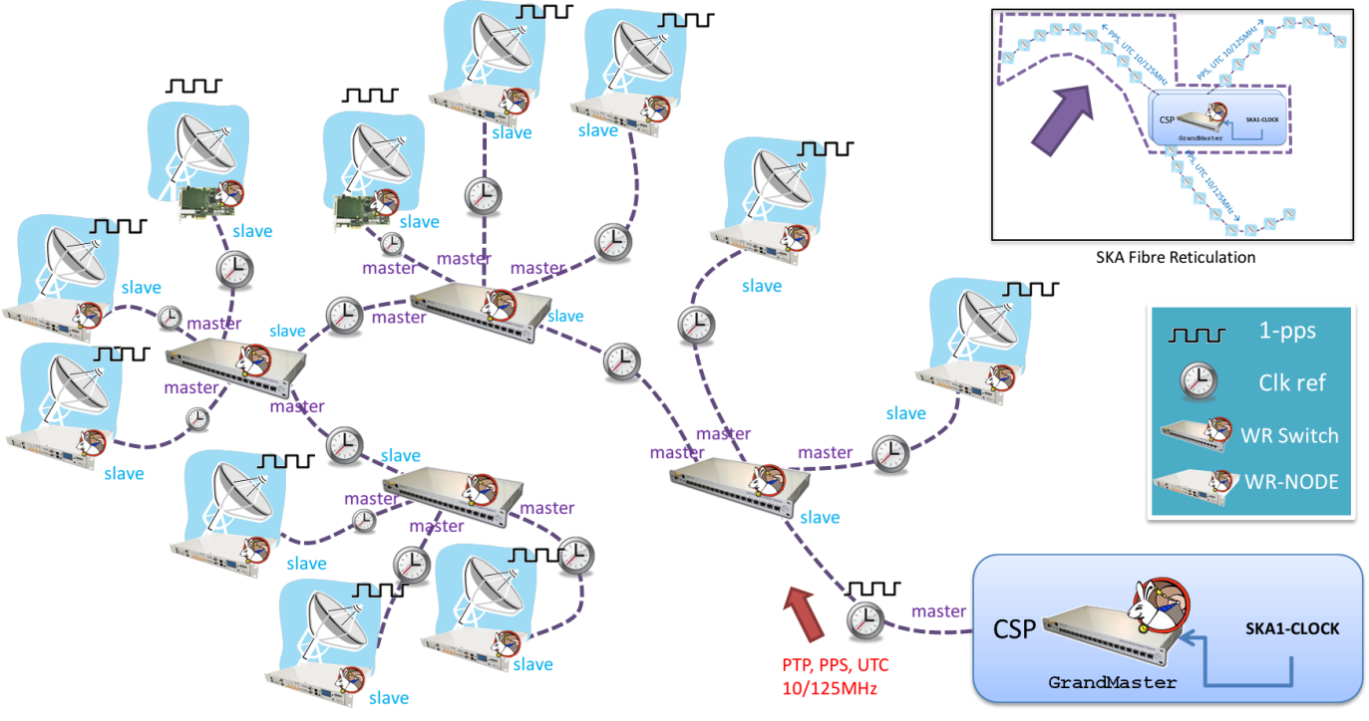

Figure . Example a network topology for PPS signal distribution based on WR switches and nodes. The figure illustrates the different elements as well as the network topology and timing signal to be distributed.

Properly speaking, the PPS pulse itself at each station is derived from the reference frequency distributed from the SKA clock and not from the WR system. The reference clock is divided down in order to provide a low jitter PPS signal. In normal operations, the WR system merely monitors the absolute time of each PPS and reports it back. If the PPS signal does not align with the start of the UTC second within the precision of the WR system, it generates an alert. This would indicate that one or more parts of the timing chain (reference frequency distribution, divider, or WR itself) have failed, and that the data from the station in question should be flagged. The WR system can be commanded to temporarily alter the division ratio to bring the PPS edge back in alignment with UTC time. Fringe finding must then be performed to restore full calibration again.

The connections between the centrally located WR switches and the WR end-nodes consist of a single strand of single-mode fibre. The optical signals are generated by industry standard bi-directional (BiDi) SFPs that use two wavelengths, one in the downlink and one in the uplink direction on the same fibre. All the fibre connections use LC/PC connectors. Finally the end nodes make a 1PPS signal available.

This solution requires WR switches and nodes. WR switches are well-defined equipment with known interfaces and software support. The problem is that the previously existing WR nodes are based on PCIe interface cards to be plugged on commodity computers, microTCA or VME-64 crates. These processor are the key element that make possible to high level services. Although most of these cards can be used on stand-alone operation mode, they just use a FPGA device as processing engine and this make very complicated to add new functionalities or include standard software tools. The inclusion of softprocessors on the FPGA gateware neither fully solves the problem because it requires using complex firmware programming tools many times out of standard application pathway or custom software development. Therefore, this solution translates on high time-intensive development effort and makes difficult the upgrade of the system firmware.

As alternative, we have proposed the utilization of the ZEN board [7]. This board is WR-compatible and powered by a Zynq FPGA-SoC device [8]. This allows developing gateware and software on the same chip, tightly integrating performance and flexibility and allowing the utilization of software-hardware codesign strategies to take full advantages of the platform. As consequence, we can save the utilization of a host computer/crate to host the FPGA card with significant reduction of the price. Furthermore, the reduction of elements (CPUs, fan, etc..) is also a remarkable improvement in term of dependability which is a key factor taking into account that SKA Telescope should have an annual availability of about 95% of the time (although degraded operation modes can be allowed under some circumstances). Finally note that all these features are possible keeping the full flexibility of a complete CPU+FPGA system on a single board.

In the following section we will describe the proposed node hardware, gateware and firmware that have been developed as a candidate solution for the SKA Telescope PPS distribution system.

YA HEMOS HABLADO DEL TELESCOPIO, DE SUS REDES, DE REQUISITOS DE SINCRONIZACIÓN Y DE LA TECNOLOGÍA ESCOGIDA. TOCA AHORA HABLAR Del nodo ZEN INCLUYENDO HARDWARE, GATEWARE, FIRMWARE, ETC.. Yo dejaba esta sección para la descripción de la tarjeta, la siguiente para el gateware y la última para el software. USA LO QUE YA TIENES ESCRITO PARA VESTIR ESTO

### A PPS DISTRIBUTION NODE ARCHITECTURE

Algún esquema de la tarjeta, del gateware, fotito del time provider (diciendo que es solución candidata para SKA), no que tenga que salir, etc…

The ZEN board is intended to be a high precise time provider and offers a large amount of possibilities facilitated by diverse connections and expansions:

- IRIG-B I/O: This is the Time of Day used by the ZEN board. It is able to work as master or slave.

- Two 10/100/1000 Ethernet ports connected to the ARM processors that can be used for diverse network applications and protocols (NTP, sNTP, PTPv2, management, etc..).

-Two SFP Cages where the WR compliant links are plugged.

-SMA connectors to enable the ZEN to synchronize itself with more precise clocks, e.g. GPS source or high stable oscillators, or providing a diverse set of clocks synchronized by WR.

- FMC connector to plug one of the mezzanine boards developed in the framework of the WR project or any other industrial one existing in the market. These FMC cards enhance the possibilities of the ZEN; e. g. FMC-ADC, FMC-DIO, FMC-FineDelay, FMC-DAC, etc; and allows many products configurations.

- Memory resources; SD, DDR3, Flash.

- Two UART-USB connectors; for management and debugging in the D-WRC and Cortex processors.

In brief, the ZEN board offers to the final user a node capable to reach sub-nanosecond synchronization, working in daisy chain schemes, and provides the best of the Zynq and its new level of system design capabilities.

Y blalbla

### A PPS DISTRIBUTION NODE ARCHITECTURE

A integrar con lo tuyo o pasar, tu mismo …

As a case of study, we can focus on the ZEN board that holds the Dual WRC (D-WRC), a revision from the original WRC developed by Seven Solution in our new line Xilinx 7 Series products. The D-WRC is able to synchronize two WR nodes or to be an intermediate link in a daisy chain network. In addition, the ZEN board includes high precision, low jitter and temperature compensated clock resources controlled by the D-WRC. Furthermore, the Dual core ARM Cortex processor, run under Linux OS, facilitating the development of user applications taking advance of the best from the WR technology and the ZEN resources. The on-board Linux allows the utilization of new and interesting features as webservices for configuration, SNMP support for status monitoring and remote firmware load and update.

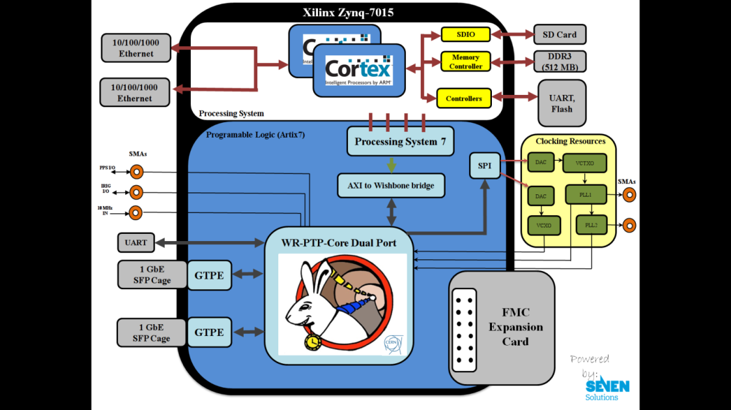

Figure 4.White-Rabbit gateware elements based on a ZYNQ device.

### PPS DISTRIBUTION NODE SOFTWARE SUPPORT

Pos POS POS

## EXPERIMENTS AND RESULTS

EXPERIMENTOS, PRUEBAS Y RESULTADOS

## CONCLUSIÓN

CONCLUIMOS QUE …

## ACKNOLEDGEMENTS

Al cern, SKA SADT, SEVEN, Emilio,

## REferencias

Para sumar….

1. Dewdney, P. 2015, SKA1 System Baseline Description v2, <https://www.skatelescope.org/wp-content/uploads/2014/03/SKA-TEL-SKO-0000308_SKA1_System_Baseline_v2_DescriptionRev01-part-1-signed.pdf>
2. Square Kilometer Array Telescope website. Available at: <https://www.skatelescope.org/>
3. SKA Signal And Data Transport element website. Available at <https://www.skatelescope.org/sadt/>
4. OHWR repository, <http://www.ohwr.org>
5. ITU-TG.8275.1/Y.1369.1 standard. Available at <https://www.itu.int/rec/dologin_pub.asp?lang=e&id=T-REC-G.8275.1-201606-I!!PDF-E&type=items>
6. WR-Switches. Available at: <http://sevensols.com/index.php/products/wr-switch/>
7. WR-ZEN nodes. Available at: <http://sevensols.com/index.php/products/wr-zen-tp/>
8. Zynq Technology, Xilinx Inc, <http://www.xilinx.com/products/silicon-devices/soc/zynq-7000.html>